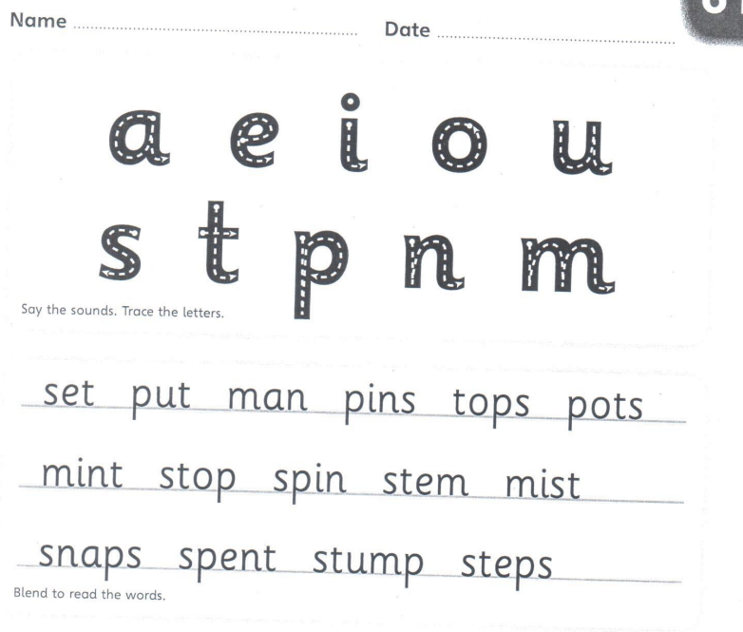

Copy the sentence out
A man put a set of pins in a pot top.
____________________________________________________________________
Now can you put spent into a sentence.
____________________________________________________________________

